Software Requirement: Anaconda
Spyder
Install Packages : pip install numpy
pandas
matplotlib
tqdm
scikit-learn
tensorflow
torch
(Note: Install all packages)
- Open the file: neetu

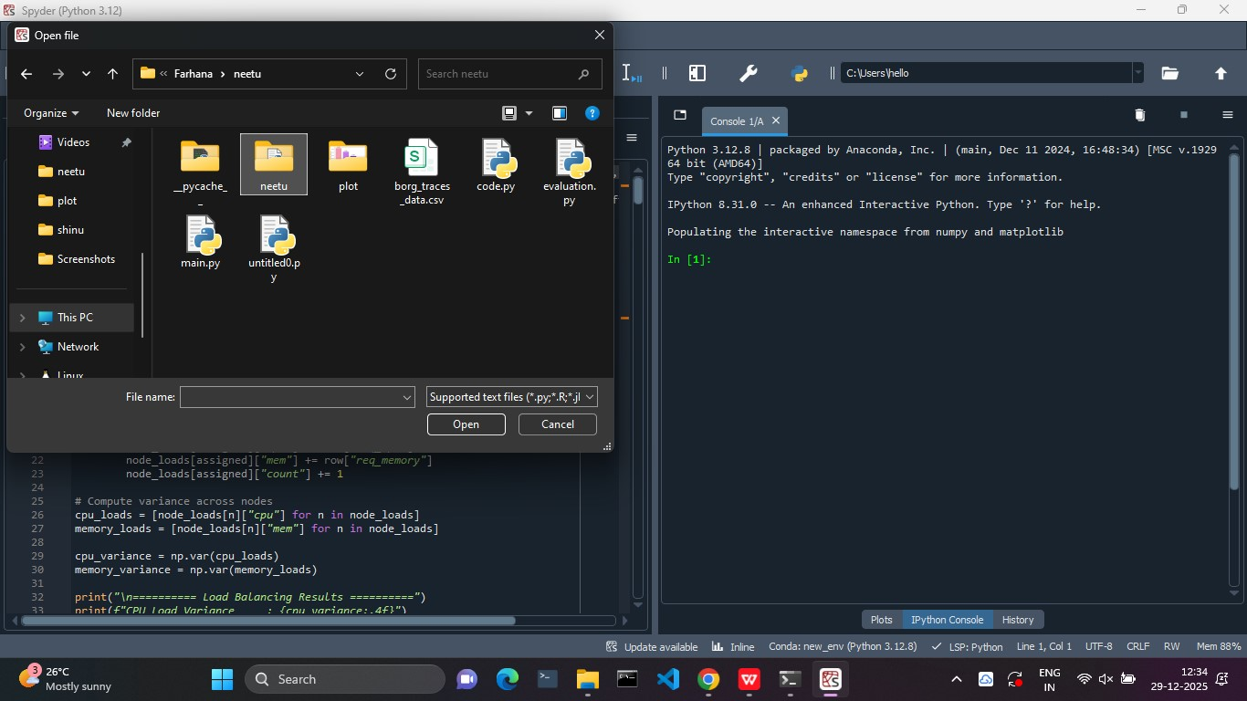

- Open main.py and evaluation.py files
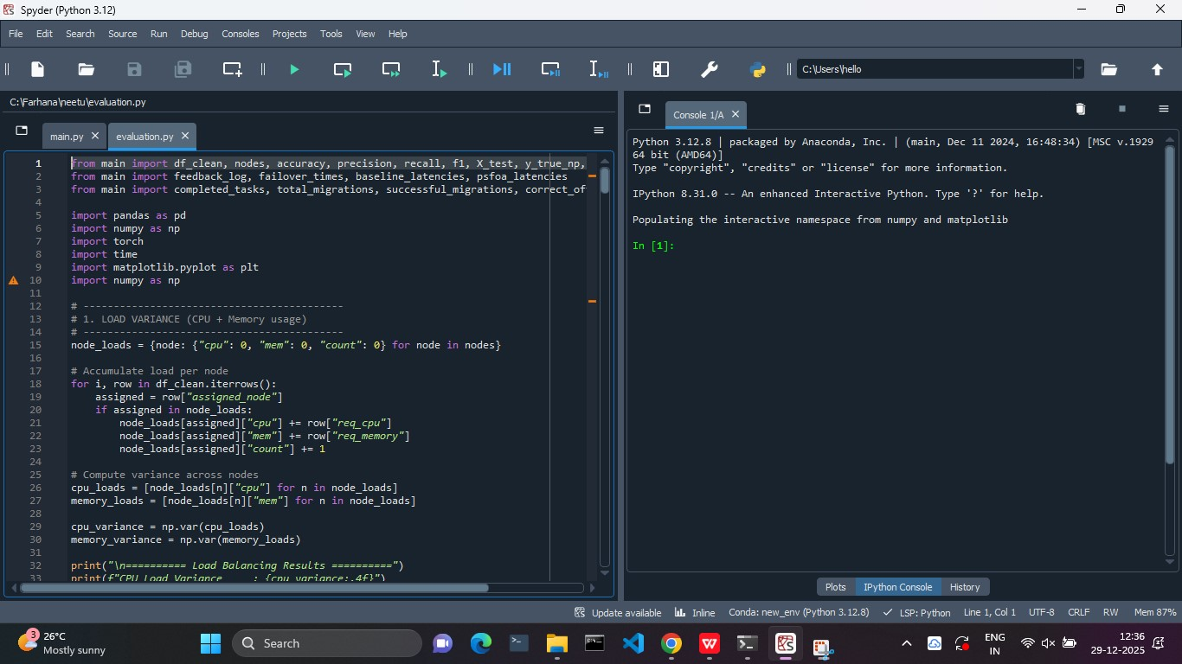
- Change the data set directory in all files
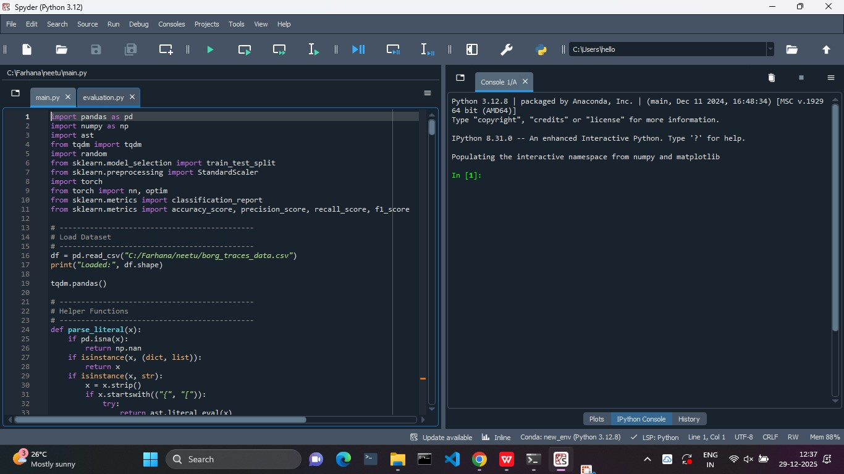

- Run the evaluation.py file

